NRL001:
- Designed a user interface to control the Dahua SD22204T-GN IP Network PTZ camera using Qt (Qt Creator & Qt Designer)
- Interface has buttons for the operator to control the movement of the PTZ camera, as well as buttons for the camera’s zoom feature
- Interface allows user to play live stream from camera or to open a local file
- Development challenges:
  - Learning Qt
  - Displaying live stream
    - Used iSpy to find webpage URL used to communicate with camera
    - Tried to play video using built in Qt Multimedia Widgets to send a network request to the URL, but had troubles playing MJPEG live stream videos, was able to play static sample WMV and MP4 videos from web
    - Used VLC-Qt library to connect to libvlc instance and player, allowing for video live stream playback
      - Had a lot of build library path errors
        - Resolved by walking through compile output step by step
        - Modified project file to allow for custom library location by mapping file to correct libraries
        - Modified general project configuration to allow qmake to generate proper Makefile
      - Video delay (suspected due to VLC player)
        - No video delay when using Qt Multimedia Widgets to play MP4 and WMV videos from web, read threads of people trying to avoid using qt-VLC player because of video delay
        - IP camera video stream not delayed through iSpy
        - Not yet resolved: look into alternative ways to display IP camera live stream such as qx11EmbedWidget and qx11EmbedContainer or Phonon
  - Figuring out how to send commands to camera for PTZ movement
    - Found XML configuration script for PTZ control in iSpy GitHub repo
    - Used signals and slots to send HTTP GET requests to configuration script URLs to allow for camera movement
  - Designed UI interface using Qt Designer, and linked that to code through Qt Creator
  - Open local file feature
    - Found Qt classes to allow users to access directory structures and select local files
  - 4 Camera frames
    - Proves that there won’t be a video delay with more cameras playing
    - App may need to have different arrow keys so operator can move different cameras
    - Modify openUrl to map each video player to the different camera URLs, create new media instances
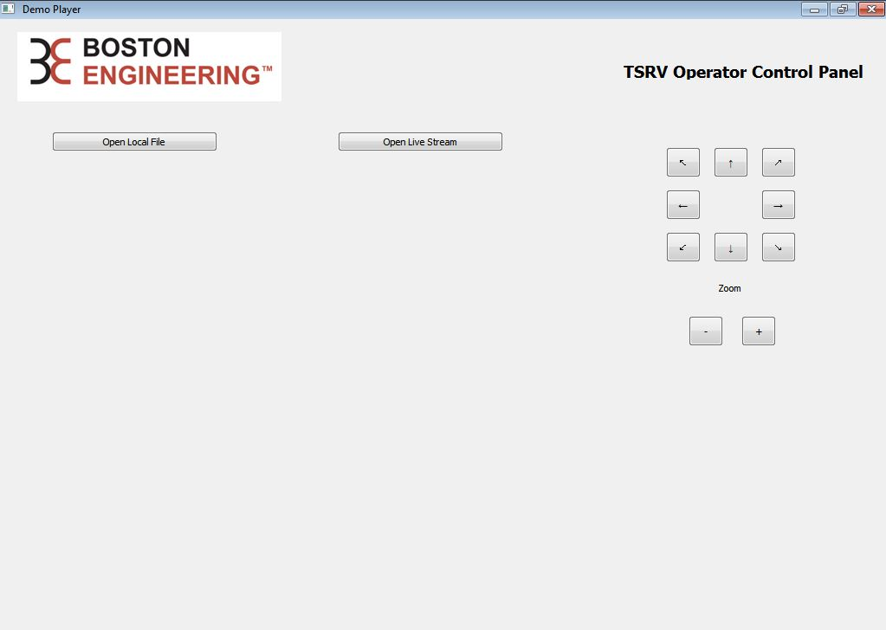

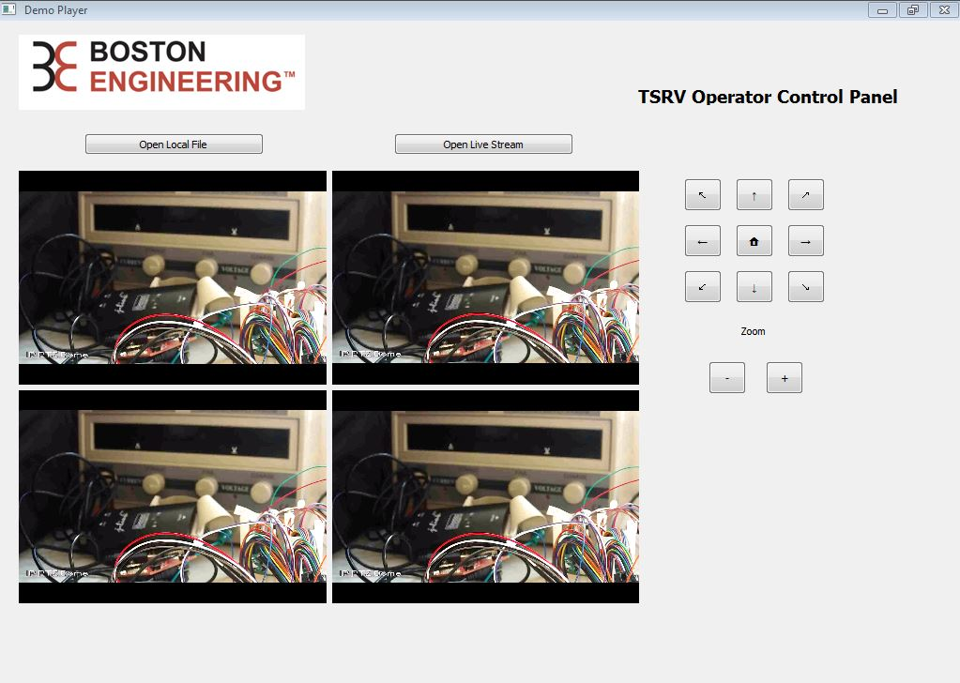
Figure 1. TSRV Operator Control Panel Interface

Figure 2. TSRV Operator Control Panel showing live stream

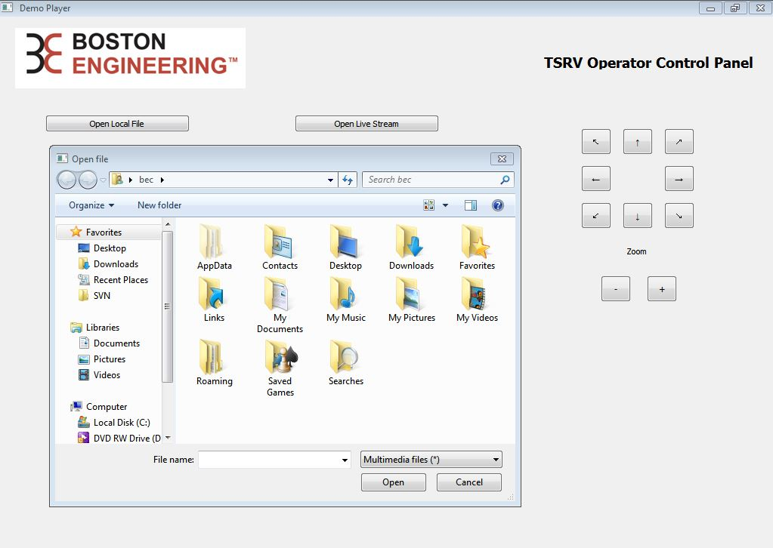

Figure 3. Interface prompting user to choose local file to play
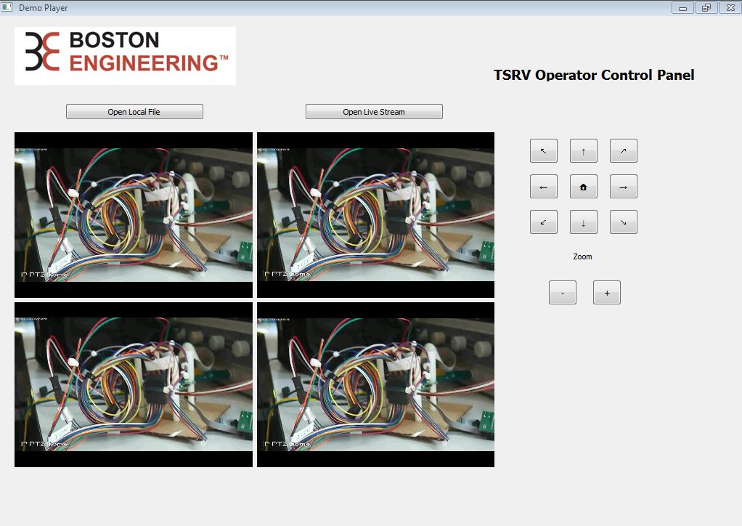

Figure 4. TSRV Operator Control Panel playing video recorded through iSpy

